NWARC
NWARC
Northwest Arkansas Rowing Center
Northwest Arkansas Rowing Center

1384 Pump Station Road
Fayetteville, AR 72701
Phone: 479.973.9037
Fax: 479.582.0216
www.nwarc.com

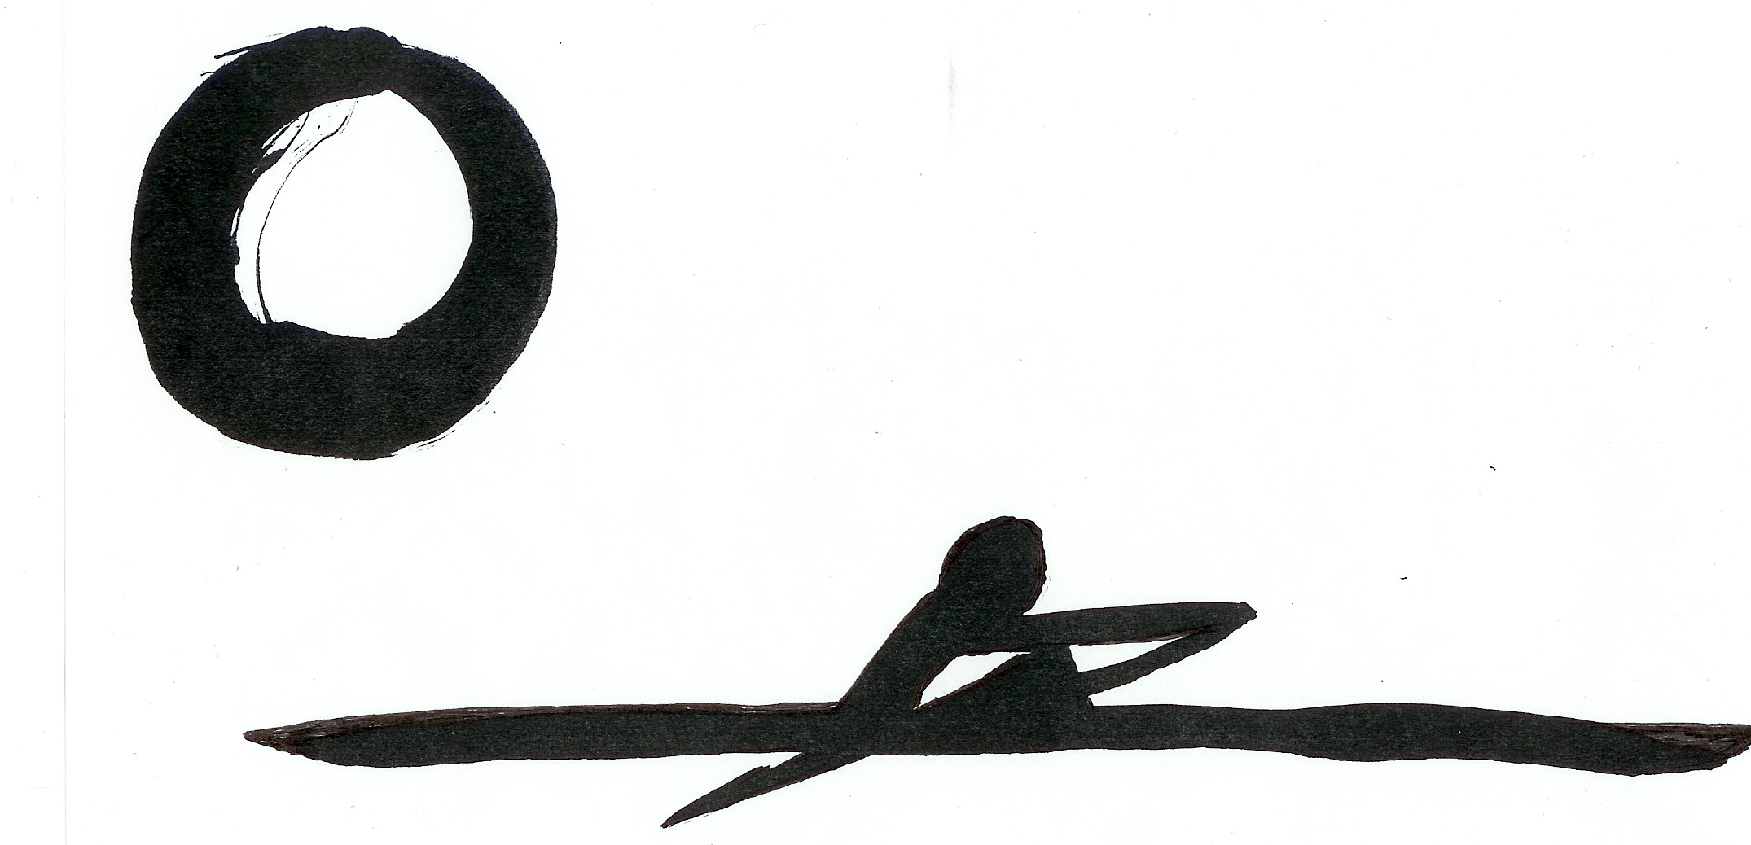

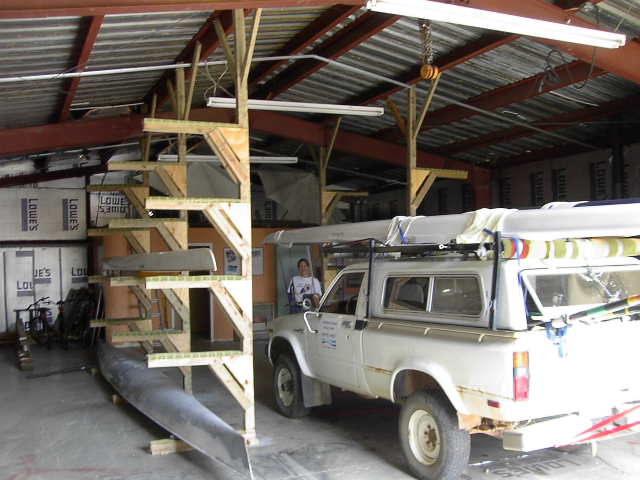
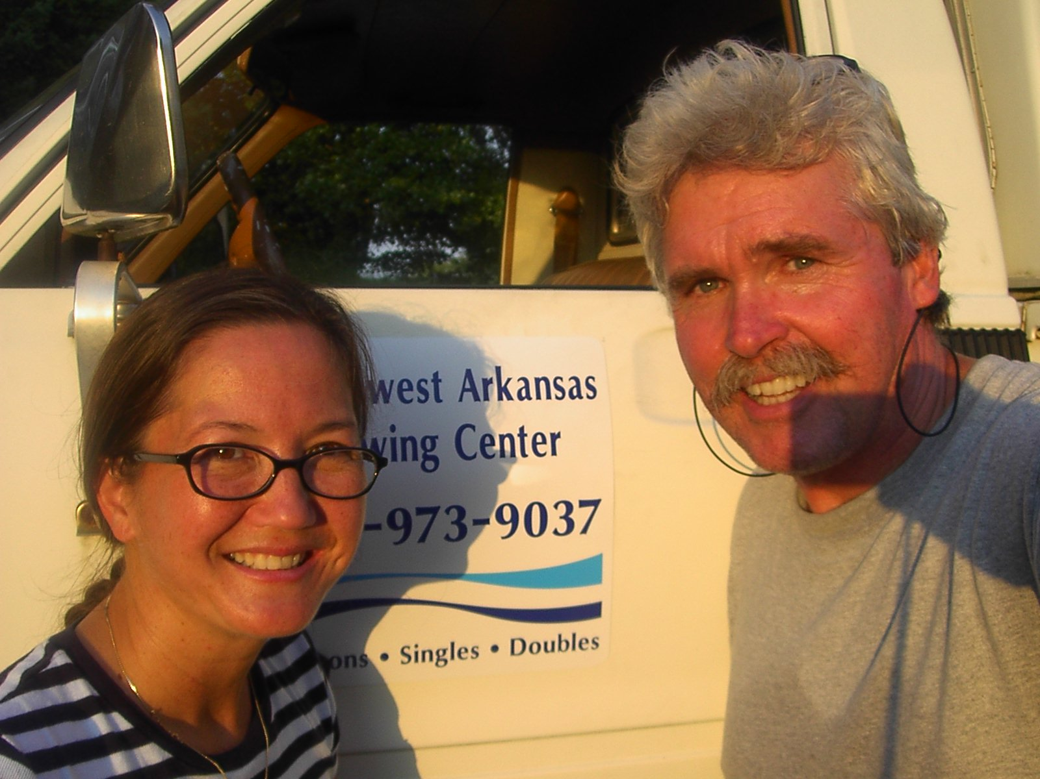
Jan & Stephen Morrill
Members USRowing
Level II Certified Instructors
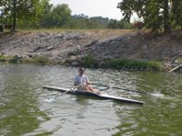
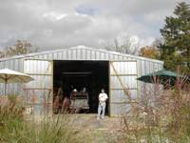

At the Northwest Arkansas Rowing Center (NWARC), our mission is to provide an introduction to the health benefits, mental discipline and pleasure of recreational rowing and sculling.
Currently, lessons, sales and storage are available through the rowing center.

NWARC

Nor

INTRODUCTION TO ROWING ($35.00)
One hour lecture format designed to teach the basics of rowing, including boat orientation, safety & maintenance, and rowing techniques.

ROWING I ($65.00)
PRE-REQUISITE: INTRODUCTION TO ROWING
Two hour “on lake” format that will begin with on-land overview of equipment, safety, rigging the boat, etc. As the student’s ability progresses, lesson will move to on-water instruction in a wide, stable single shell.

ROWING II ($75.00)
PRE-REQUISITE: ROWING I
Two hour continuation of “on-lake” format. Upon demonstration of student ability, student will receive further instruction in rowing on the lake, including improvement of form, turning the boat, etc.

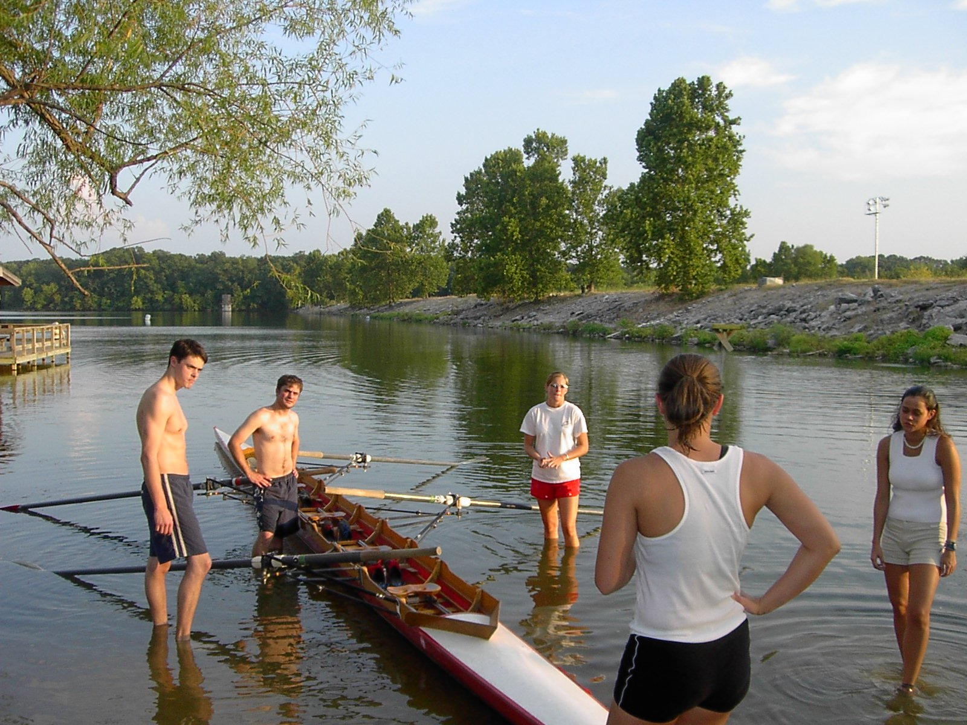
University of Arkansas Rowing Team at Lake Fayetteville

PRIVATE LESSON ($45.00/HOUR)
Requires completion of Rowing I & Rowing II.

BOAT STORAGE ($22.00/MONTH)
Access to boat house via combination lock. Requires completion of Rowing I & Rowing II, current membership and proven ability to row.

